- Forceps (pickups)
  - 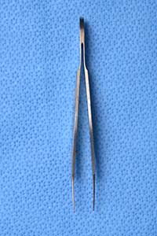
- Wescotts (mimes scissors)
  - 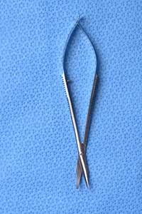
- Needle Driver (Swoops hand like sewing)
  - 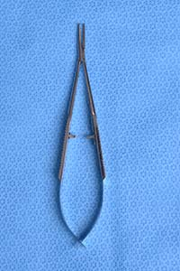
- Punctal dilator (dilator)
  - 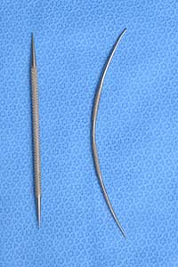
- Punctal probe/Bowman Probes (probe)
  - 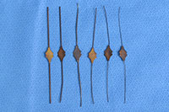
- Desmarres
  - 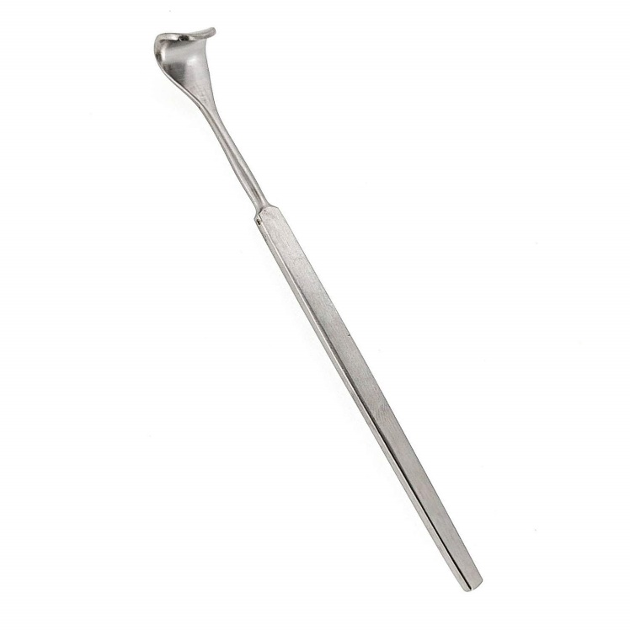
- Eyelid Plate (plate)
  - 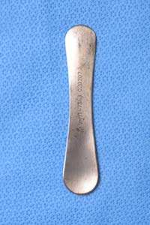
- Blade Handle (15 blade, scalpel)
  - 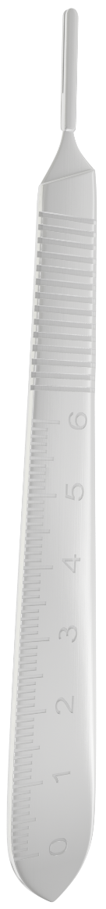
- Lac Tip (irrigation)
  - 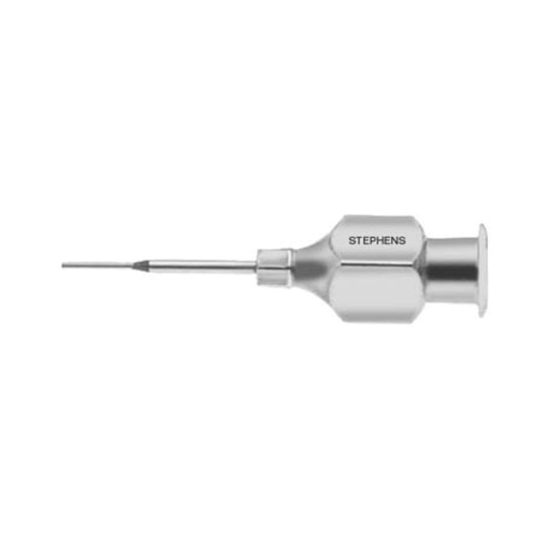
- Two Prong Rake (skin hook)
  - 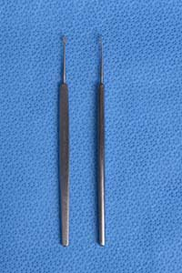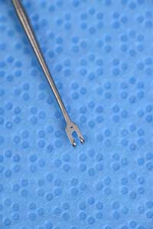
- Four Prong Rake
  - 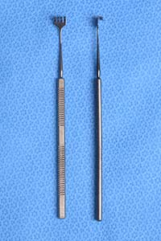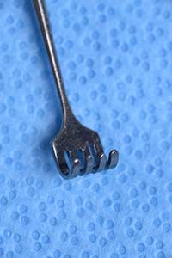
- Calipers
  - 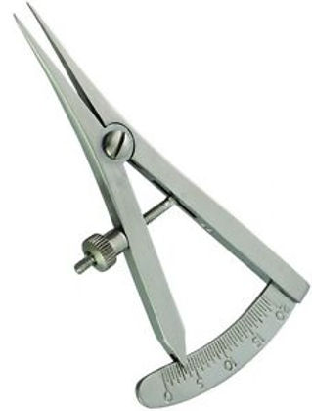
- Clamp for ILR (Putterman Forceps) (clamp)
  - 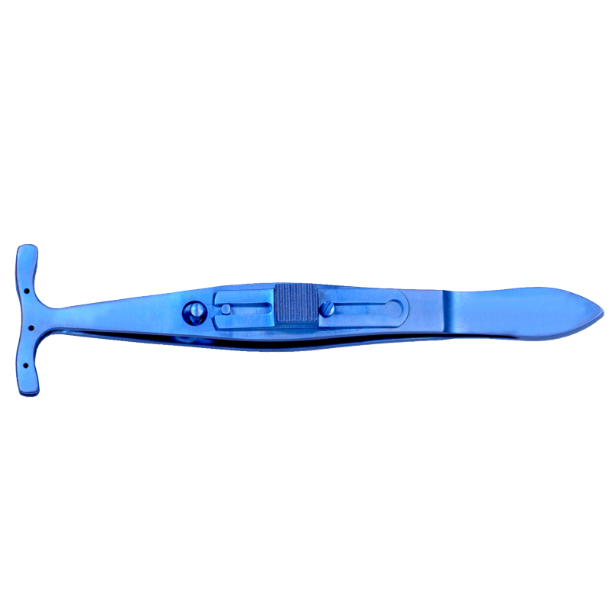
- Hemostat
  - 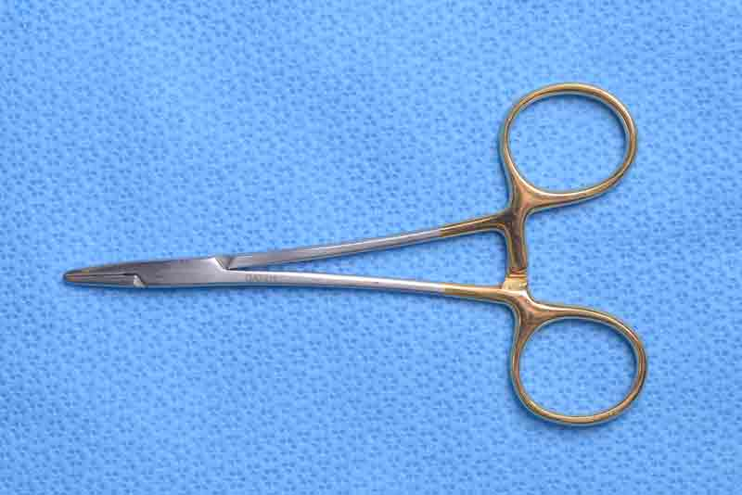
- Tenotomy Scissors
  - 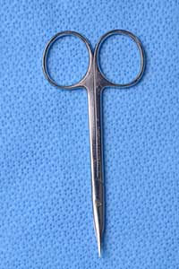
- Adson Forceps
  - 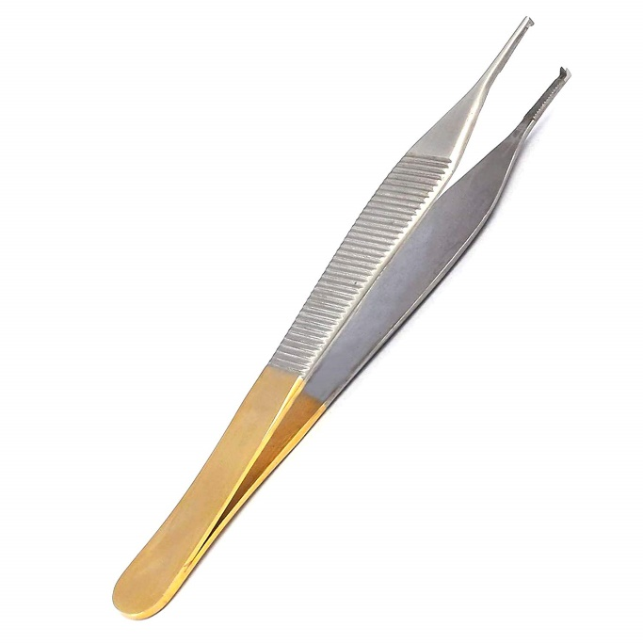
- Vanna Scissors
  - 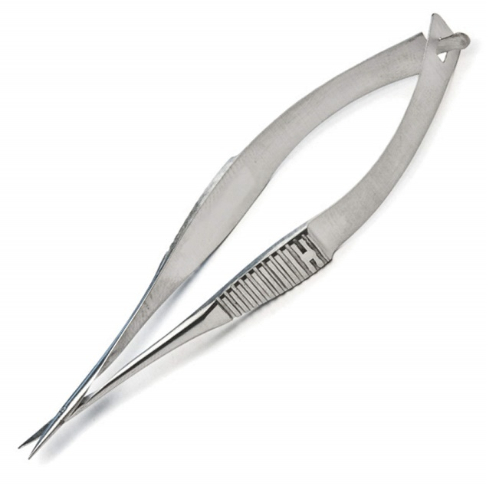
- Eye Shields
  - 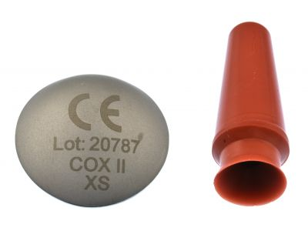
- Eyelid Clamp (chalazion clamp, clamp)
  - 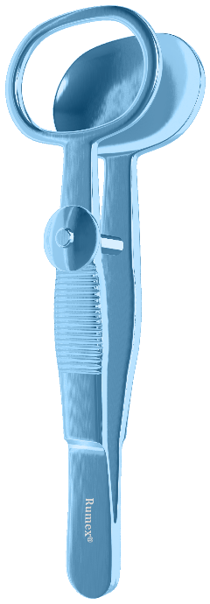
- Freer Periosteal Elevator (Freer, Elevator)
  - 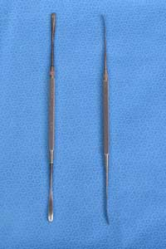
- Frazier Suction Tip (Suction)
  - 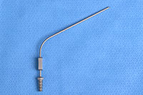
- Bipolar Forceps (bipole)
  - 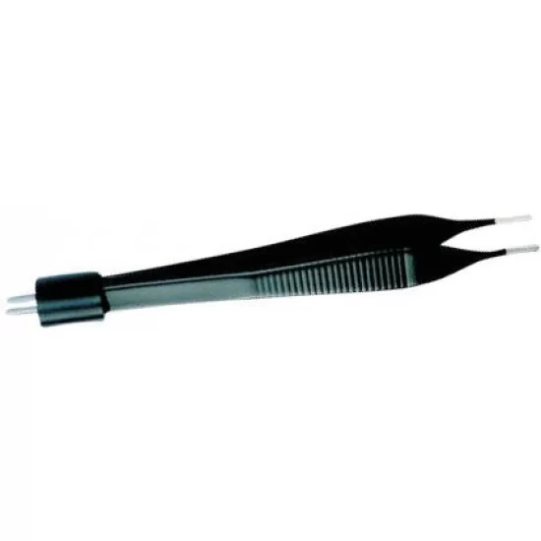
- Bipolar Cord
  - 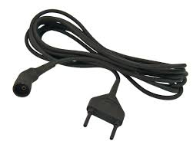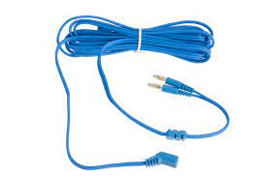
- Curette
  - 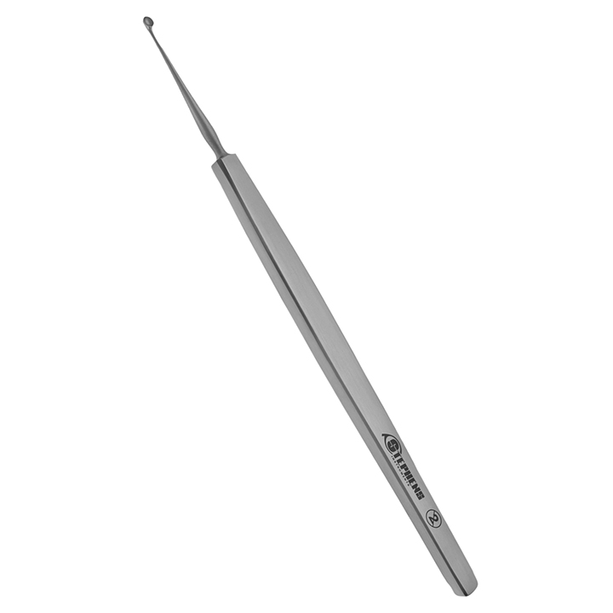
- Bayonet Forceps
  - 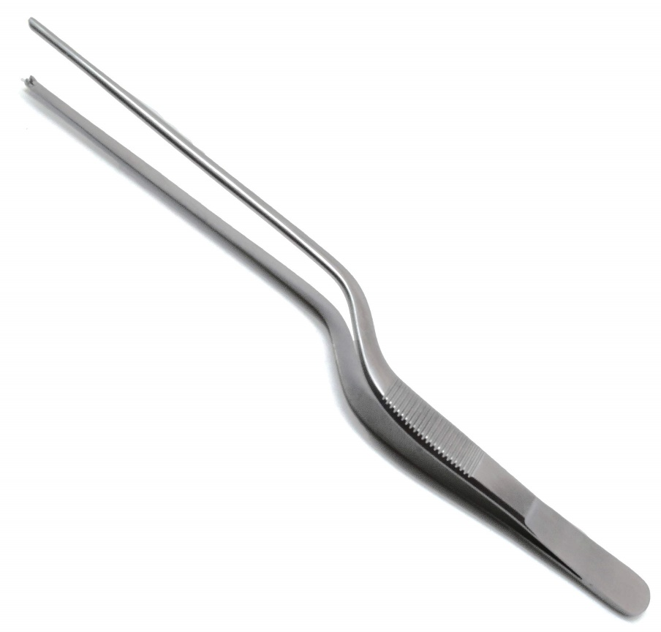
- Jewelers
  - 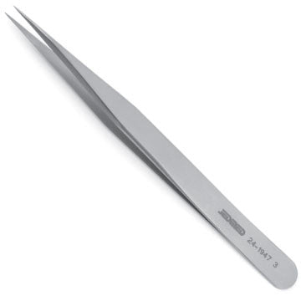
- Hot Temp
  - 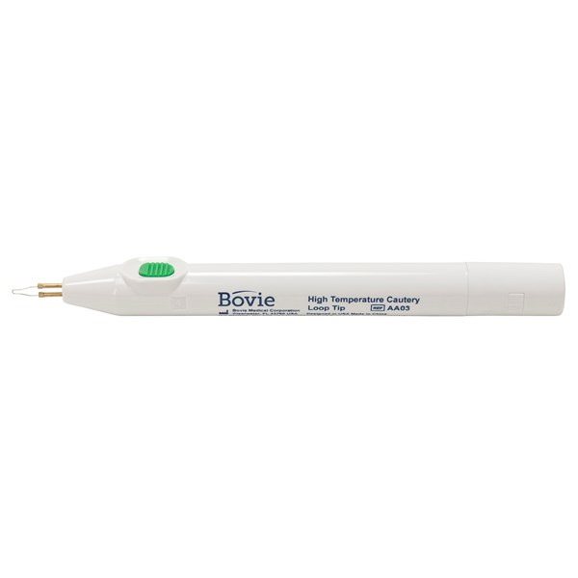

In the surgery center, He sometimes calls the monopolar a yellow tip or a bovie

DCR:
- Previously mentioned: freer elevator, all stuff in normal set, suction tip, hemostat, 4 prong rake, punctal dilator, bowman probe
- Bayonet Forceps
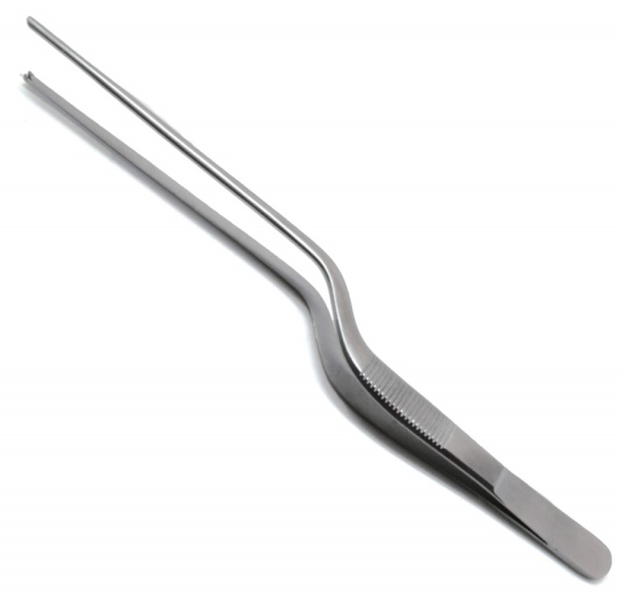
- Nasal speculum
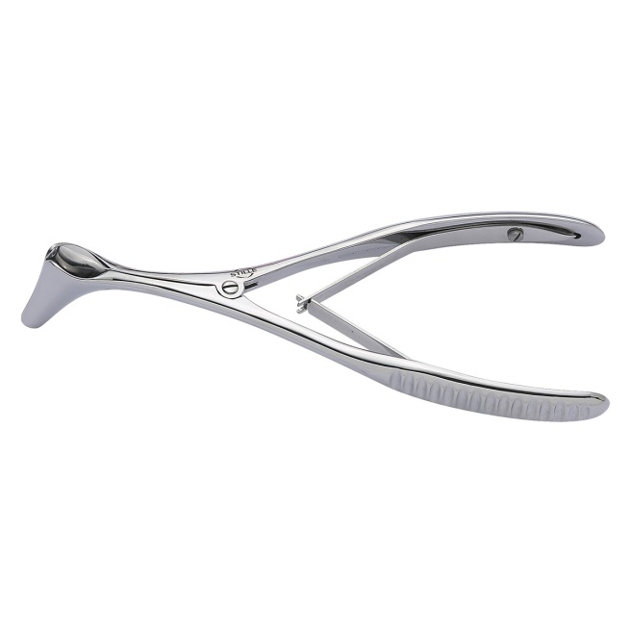
- Kerrison Rongeurs (aka hole punch)
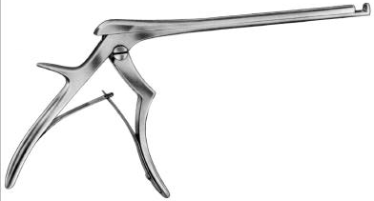
- Beaver blade (not sure if will use)
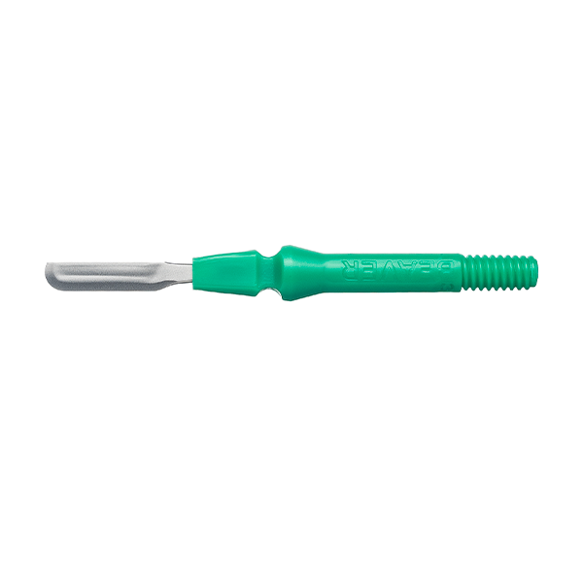
- Crawford hook
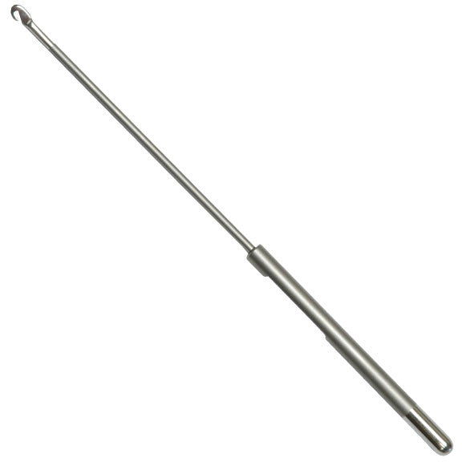
- Grooved director
